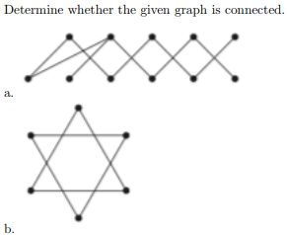

If we can connect one vertex to another vertex through a path, it’s a connected graph.
- a) The graph is connected, as any two vertices can be connected by some path
- b) This graph is not connected, as it consists of two 3-vertex groups, and although vertices of one group are connected, there’s no path connecting vertices of different ”groups”

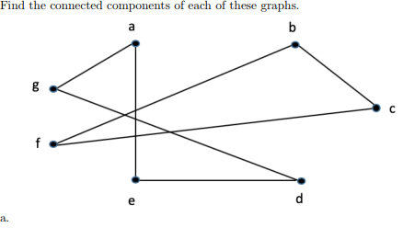
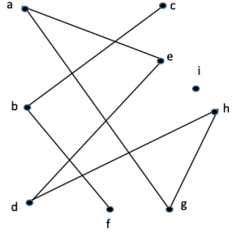

Find the connected sub-graphs of the graph that are made-up within the original graph
- a. The vertices {a, d, e, g} along with edges { {a,e},{a,g},{d,e},{d,g} }, and vertices {b, c, f} along with edges { {b,c}, {b,f}, {c,f} }are the connected components of the graph
- b. The vertices {a, d, e, g, h} along with edges { {a,e},{a,g},{d,e},{d,h},{g,h} }, vertices {b, c, f} along with edges { {b,c}, {b,f} }, and vertex i are the connected components of the graph

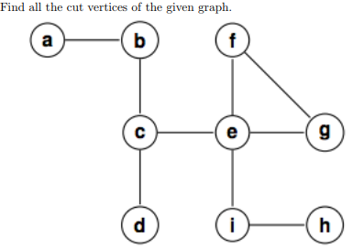
The cut vertices are b, c, e, and i.
Removing any of these makes a
disconnected graph.

A pendant vertex of a graph is a vertex with degree of 1. Suppose that v is an endpoint of a cut edge. Prove that v is a cut vertex if and only if this vertex is not pendant.
- Simple Way of Answering: A pendant vertex is a vertex with a degree of 1, so that means if we try and remove it then it wouldn’t really disconnect the graph since it only removes an end-point of the graph, which cutting end-points doesn’t cause a disconnected graph.
- Formal Way of Answering: Without loss of generality, we can restrict our attention to the component in which the cut edge lies; other components of the graph are irrelevant to this proposition. To fix notation, let the cut edge be uv.
  - When the cut edge is removed, the graph has two components, one of which contains v and the other of which contains u. If v is pendant, then it is clear that the removal of v results in exactly the component containing u, a connected graph. Therefore v is not a cut vertex in this case.
  - On the other hand, if v is not pendant, then there are other vertices in the component containing v, at least one other vertex w adjacent to v. (We are assuming that this proposition refers to a simple graph, so that there is no loop at v.) Therefore when v is removed, there are at least two components, one containing u and another containing w.

Explain the procedure for constructing an Euler circuit in a graph.
- Make sure your graph has either 0 or 2 vertices of odd degree.
- If there are no odd vertices, start at any vertex. Otherwise, start at either of the vertices with odd degree.
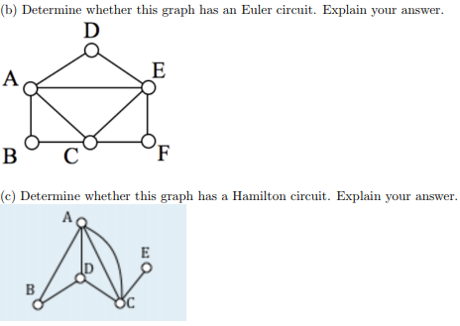
- Follow the edges one at a time. Each edge will either be a bridge or a non-bridge. If possible, always choose a non-bridge. Stop when you run out of edges.

b) Yes. One example is if you start at vertex A, then you can make ADEACEFCBA.
c) No. Vertex E has a degree of 1, which by definition cannot be a Hamilton Circuit. There is no way of leaving E without returning to C. However, we do have Hamilton Paths like ECDAB.

Give an example of a simple graph with with n vertices with n ≥ 3 that does not have a Hamilton circuit, yet the degree of every vertex in the graph is at least (n − 1)/2.
